Step 0 Intake + Interview Filing Status, Dependency

Interview Notes: (See also: General Notes)
- George was a full-time student at a local college
- Neither George nor Susan made over $4,150 in TY 2018
- Neither George nor Susan qualified for a “Multiple Support Declaration”
- Mary paid $144 in Student Loan interest during the tax year
- The Browns paid $9,000 in rent while living in Dover through June (They had lived at the Dover address for many years)
- The Browns moved in July when they inherited a house in Denville. They paid $4,534 in property taxes but had no mortgage payments. According to the postcard from the tax office: – Block=50001, Lot=00002, Qualifier is blank.
- Henry started receiving his pension from Fidelity this year
- Neither Henry nor Mary are Veterans.
- The Browns filed for and are eligible for a Homestead Benefit property tax credit
- The Browns all had health insurance for the entire tax year
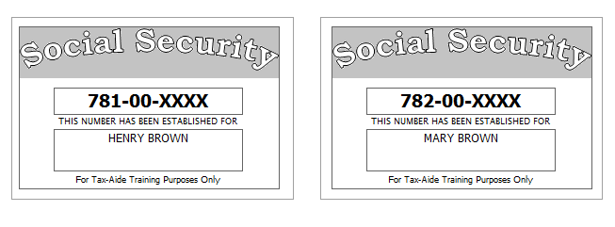
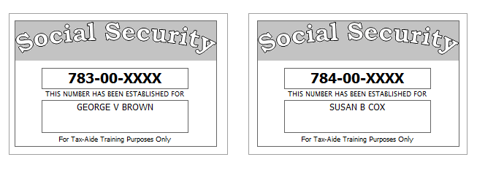

Step 1 Basic Information
TP Form / Note | TS Screen | Notes
SS Card | Start a New 2018 Tax Return  Available Taxpayer Profiles | TS: Ignore the Profiles  TS: Select “Enter Social Security Number” at the bottom of the screen  TS: Enter the TP SSN twice and “Start Return”
Intake Sheet | What is your filing Status? | TS Answer: Filing Status: Married filing joint  TS: “Continue”
SS Card  Intake Sheet  G-Note 2 | Personal Information  Taxpayer Information  Spouse Information  Address & Phone Number | TS: Enter all information using “Caps Lock”  Hint: Use Name and SSN from SS card. (Not Intake Sheet)  Hint: SSN format YYY-00-0752  TS: Birth date can be entered using drop down menu or filling in the field.  TS: Check any of the “Check here” questions that apply –  - TS- Check presidential election campaign fund for SP  TS: Spouses last name auto populates when field is selected. Change if required.  TS: Enter Zip code- TaxSlayer fills in city and state. Correct if required  TS: New Jersey automatically populates as the Resident State  TS: “Continue”
I–Note 6 &10 | New Jersey Return  NJ Property Tax Credit or Deduction  Do you meet Property Tax  Credit or Deduction  Eligibility Requirements?  Taxpayer NJ Health Insurance  Does the Taxpayer have  Health Insurance?  Does the Spouse have  Health Insurance?  New Jersey Return  Select the County or  Municipality of your  current residence | Hint: Begin NJ Checklist  .  TS Answer: At this point answer “No”. We will go back and adjust after the Federal Return is complete  TS Answer: “Yes”  TS Answer: “Yes”  Use “NJ Municipality Code lookup in Tax Prep 4 Free  Left click in the box. Type in Morris. Scroll down to MORRIS COUNTY-DENVILLE TWP  At this point just hit ““Continue”” We will go back and adjust after the Federal Return is complete
I-Note 1 | Dependents or Qualifying Person(s)  Do you have any dependents or qualifying person(s) to claim on your return? | TS: Select Yes
Intake Sheet, SS Card  I-Note 1,2,3 | Dependent/Qualifying Child  Information | Add dependent information  Hint: Use name and SSN from SS card (Not Intake Sheet)  TS: Last name auto populates. Change if required  Answer: SSN format = YYY-00-0752  TS: Check the “Check All That Apply” questions that apply  - Hint: Both dependents are U.S Citizens and full-time students, but only George is over 18 and a full-time student at an eligible educational institution  TS: Add second dependent information  Hint: Susan’s last name is Cox. Make the change.  TS: Select ““Continue””, ““Continue””, ““Continue””

Federal AGI: 0 Federal Refund: 0 NJ Refund Amount: 0

Step 2 SSA-1099
TP Form / Note | TS Screen | Notes
SSA-1099 | Left Menu -Federal Section  Income  IRA/Pension Distribution Form 1099-R/RRB/SSA  - Begin  Social Security Benefits/RRB-1099  -Begin | TS: Enter SSA-1099 Data  Hint: Use TP4F Scratch Pad to document Medicare Parts B, C, D. Insert total in “Taxpayer’s Medicare Premiums”. Amount = $1,889  TS: ““Continue””, ““Continue””

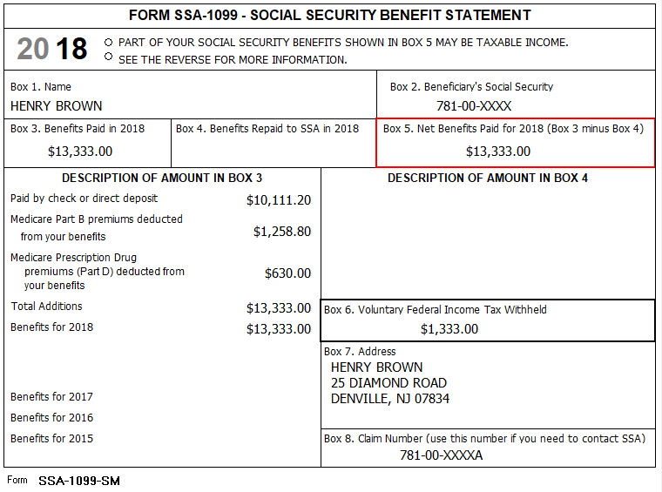

Federal AGI: 0 Federal Refund: 1,333 NJ Refund Amount: 0
Step 3 W-2 Green Grass Golf
W-2  Green Grass Golf | Left Menu - Income  Wages & Salaries Form W-2  Complete W-2 Information-  Begin | Hint: This is Henry Brown’s W-2  Hint: Make corrections so that information matches the information on the paper W-2.  - TP address shown on the TS W-2 should match the paper W-2  - If the name and address of the employer come up after inputting the employer Identification Number, check that the information matcher the paper W-2  Hint: Always round up for cents amounts ending in .50 or enter cents and TS will round it for you.  Hint: Box 14 NJ Codes are selected from drop down menu. All other entries in box 14 are lumped under “Other”  Hint: If NJ State EIN auto populates, check to be sure it is correct  TS: Click Save & Enter Another
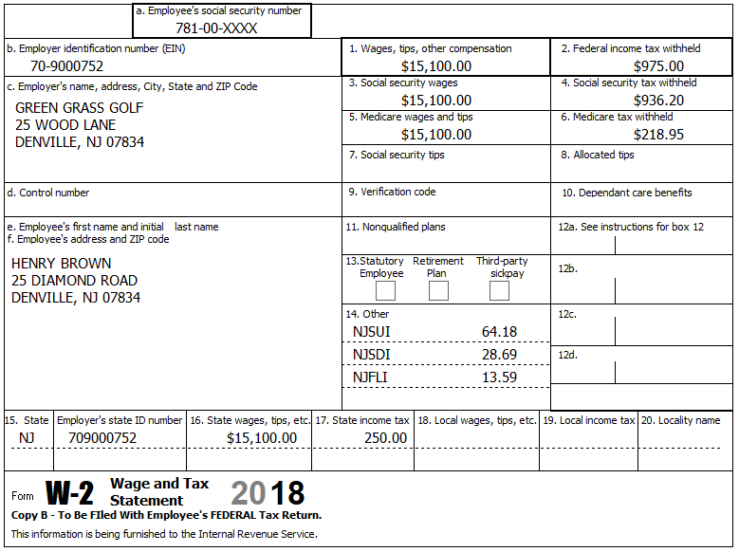

Federal AGI: 15,100 Federal Refund: 8,024 NJ Refund Amount: 2,365

Step 4 W-2 Joe’s Bar & Grill
TP Form / Note | TS Screen | Notes
W-2 Joe’s Bar & Grill | Add W-2 Statement | Hint: This is Mary Brown’s W-2  Hint: Make corrections so that information matches the information on the paper W-2.  - TP address shown on the TS W-2 should match the paper W-2  - Mary’s address on the paper W-2 differs from the electronic W-2. Make the correction  - If the name and address of the employer come up after inputting the employer Identification Number, check that the information matcher the paper W-2  - Check boxes 3-7 for correct entries  TS: Certain characters are not allowed for E-File (#, ‘). TS will remove them once the form is saved  TS: Always round up for amounts ending in --.50  Hint: Box 14 NJ Codes are selected from drop down menu. All other entries in box 14 are lumped under “Other”  Hint: If NJ State EIN auto populates, check to be sure it is correct  TS: Click “Continue”  TS: Warning Message: Be sure the numbers entered are the numbers on the TaxSlayer W-2. Click on “Cancel”, check numbers, click “Continue” and then click ““Continue”” on the message.
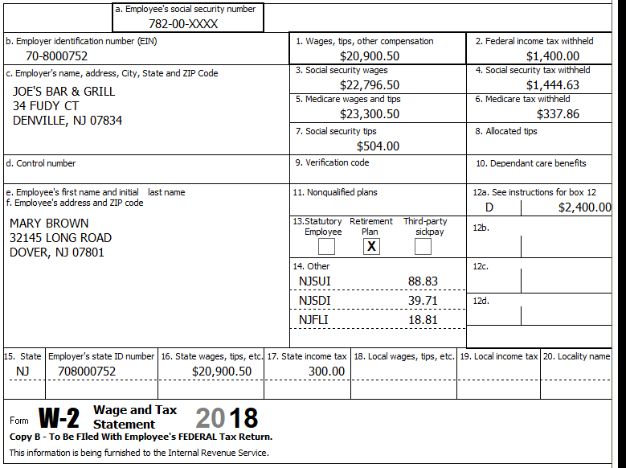

Federal AGI: 41,335 Federal Refund: 5,446 NJ Refund Amount: 908
Step 5 Interest 1099-INT
TP Form / Note | TS Screen | Notes
1099-INT  National City Bank | Left Menu - Income  Interest and Dividend Income, Form 1099-INT/ 1099-DIV  - Begin  Interest or Dividend Income -Begin  Interest Income, Form 1099-INT,Form  1099-OID  -““Continue”” | Hint: Select for Taxpayer  Enter values that apply.  Hint: It is not required to enter the EIN and address.  ““Continue””

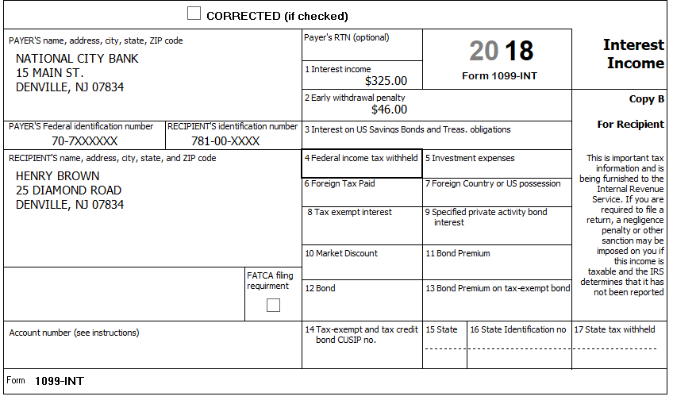

Federal AGI: 41,754 Federal Refund: 5,306 NJ Refund Amount: 867

Step 6 Dividends 1099-DIV
TP Form / Note | TS Screen | Notes
1099-DIV  Dreyfus | Add an Interest and Dividends  Dividend Income, Form 1099-DIV  “Continue” | Hint: Select for Taxpayer  Enter values that apply  “Continue”
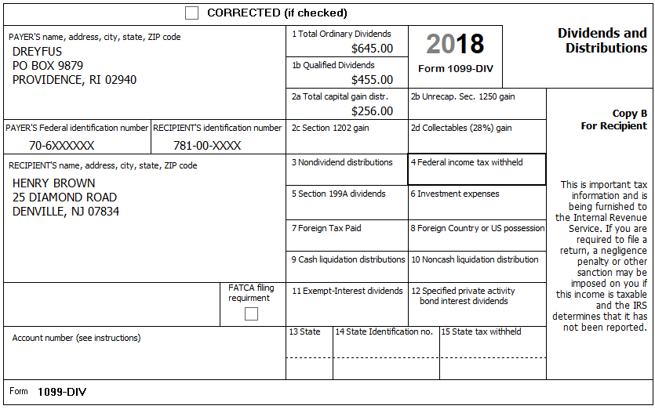

Federal AGI: 43,105 Federal Refund: 4,962 NJ Refund Amount: 747

Step 7 1099-R

TP Form / Note | TS Screen | Notes
1099-R  Fidelity Investments | Left Menu -Federal Section- Income  IRA/Pension Distribution Form 1099-R / RBA, SSA  – Edit  Add or edit a 1099-R  -Begin | Hint: “This 1099-R is for Henry  Hint: Make corrections so that information matches the information on the 1099-R  Hint: Taxable amount defaults to Gross Distribution Amount. Adjust as required.  TS: You do not have to select a State for income to go to the State return.  TS: “Continue”
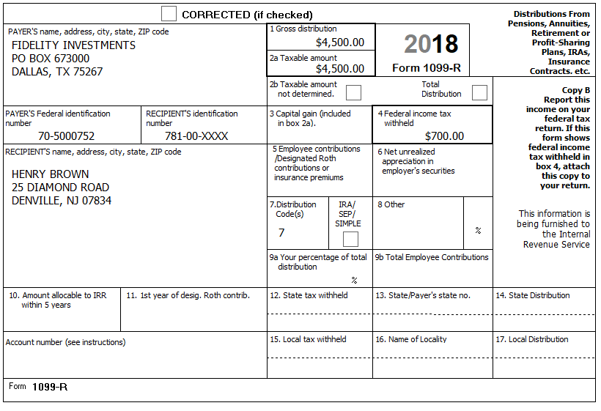

Federal AGI: 51,377 Federal Refund: 2,769 NJ Refund Amount: 104

Step 8 Unemployment 1099-G

TP Form / Note | TS Screen | Notes
1099-G  NJ Dep. of Labor | Left Menu- Federal Section - Income  UnemploymentCompensation Form 1099-G Box 1  – Begin  Add or Edit a 1099-G  - Begin | TS: This 1099G worksheet is for Mary Brown  Hint: Phone number not required  Hint: State information not required  “Continue”
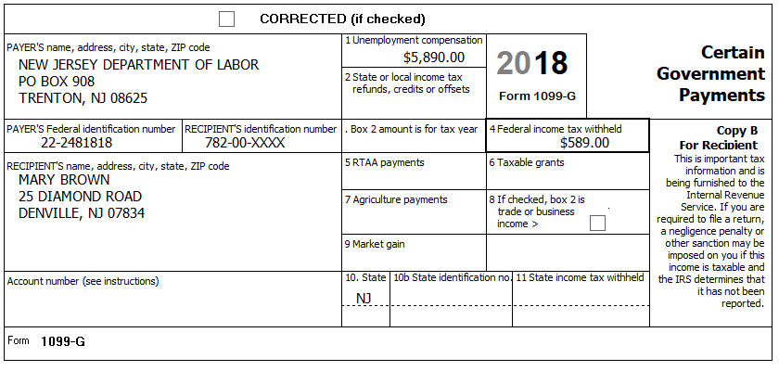
Federal AGI: 58,904 Federal Refund: 2,433 NJ Refund Amount: 95
Step 9 Student Loan Interest
TP Form / Note | TS Screen | Notes
I-Note 2 | Left Menu  Federal Section – Deductions  Enter Myself  Adjustments - Begin  Student Loan Interest Deduction - Begin | Enter Student Loan Interest Amount  “Continue”

Mary paid $144 in Student Loan interest during the tax year

Federal AGI: 58,760 Federal Refund: 2,451 NJ Refund Amount: 95
Step 10 Itemized Deductions – Taxes You Paid
TP Form / Note | TS Screen | Notes
I-Note 4 | Left Menu-Federal Section -Deductions – Enter Myself  Itemized Deductions – Begin  Taxes You Paid - Begin | TS: Go to ADD SALES TAX WORKSHEET and enter ZIP Code and 365 days living in NJ  TS: Enter real estate taxes paid  ““Continue””

The Browns moved in July when they inherited a house in Denville. They paid $4,534 in property taxes but had no mortgage payments.
Federal AGI: 58,760 Federal Refund: 2,451 NJ Refund Amount: 95
Step 11 Compare Standard vs Itemized Deductions

TP Form / Note | TS Screen | Notes
 | Federal Section  Deductions  Enter Myself  Compare Deductions - Begin | TS: Check to see if using itemized or standard deductions.  Itemized = 5,393 Std = 25,300  Hint: You can view Schedule A (Itemized Deductions) by clicking on the Print Icon next to Itemized Deductions in the Deductions Menu.  “Continue”

Federal AGI: 58,760 Federal Refund: 2,451 NJ Refund Amount: 95
Step 12 Health Insurance

TP Form / Note | TS Screen | Notes
G-Note 2  I-Note 10 | Left Menu-Health Insurance  Health Insurance Questionnaire  Did you or your family have health insurance or qualify for a coverage exemption at any time in 2018?  “Continue”  Did you purchase insurance via HealthCare.gov of a State Marketplace?  “Continue”  Verify Your Household Members  “Continue”  Months Insured  Was your entire household covered by qualifying health care coverage or a coverage exemption that covered 2018 or a combination of qualifying health care coverage and coverage exemptions for every month of 2018? | Answer questions in the Health Insurance Section  TS – Yes  TS – No  TS – Always select ““Continue””  TS-Yes  “Continue”

Every person on the return had health insurance that met Minimum Essential Coverage rules for the entire year. They did not purchase it through the marketplace.

Federal AGI: 58,760 Federal Refund: 2,451 NJ Refund Amount: 95

Step 13 New Jersey Return

TP Form / Note | TS Screen | Notes
I-Note 1,5,6,8,9,10  G-Note 2,3,4 | State Return –Edit  Basic Information - Edit  Credits  - Property Tax Credit/Deduction-Begin | Hint: Use the NJ Checklist to enter NJ items  TS: Complete Basic Information  Hint: George is attending college, but he is not under 22 years of age.  Hint: Gubernatorial Election Fund: Henry – No, Mary - Yes  Save  Hint: Taxpayer meets Property Tax Eligibility Requirements  Hint: Use scratch pad at TP4F to determine the proper value for Property Tax Paid  - Hint: Property Taxes Paid = (rent*.18) + Property taxes paid (9,000*.18) + 4,534 = $6,154  Hint: Taxpayer was a homeowner in 2018  Hint: Brown filed for homestead benefit  Hint: Enter the Block and Lot numbers  Hint: County Property Located in Denville.  Save back to the beginning of the State Return

The Browns paid $9,000 in rent while living in Dover through June (They had lived at the Dover address for many years)
The Browns moved in July when they inherited a house in Denville. They paid $4,534 in property taxes but had no mortgage payments. According to the postcard from the tax office: – Block=50001, Lot=0002, Qualifier is blank.
The Browns filed for and are eligible for a Homestead Benefit property tax credit
County Property located in: Morris-Denville
They had no out-of-state purchases on which they did not pay Use tax

Federal AGI: 58,760 Federal Refund: 2,451 NJ Refund Amount: 202

Step 14 Prepare for e-file
Intake Sheet  G Note 5 | Left Menu – e-file –  Federal Return Type  Fees  State Return Type  Bank Accounts  Third Party Designee Info  Consent to Disclose  Questions  Taxpayer ID Information | TS – Clear up any diagnostic messages (if any)  TS: Select “E:file: Direct Deposit”  Next  TS: No entries in Fees section except for Client email address  Next  TS: Select State Refund Type “E:file: Direct Deposit”  Next  TS: Enter Bank Information –  - Account Type - Checking  - Name of Bank not required.  - Deposit amount is required. Click “PULL REFUND”  - Enter Routing and Account numbers twice  Next  TS: Skip Third Party Designee. It is Out of Scope for us.  Next  TS: Consent to Disclose Tax Return Information – Check GRANT  and enter 5 digit pin (any 5 digit number) and date for TP and SP  Next  TS – Questions – Answer questions from Intake sheet Part VII, lines 5.6,7 and 8  - Assume taxpayer was present  Next  TS: Skip TP ID Information Screen. Not required for NJ.  Save  You are Done

They want to handle any state refund / amount due like their federal refund / amount due
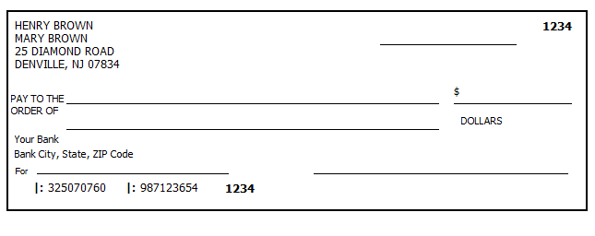
Federal AGI: 58,760 Federal Refund: 2,451 NJ Refund Amount: 202

